**Question 1**

“It is easy to make a *user interface* but it is hard to make a good one” (Lauesen, 2005).

(a) Describe what a user interface is. Give 2 e.g. **(*own examples*)** to support your answer.

UI is the contact point between a user and a machine (HCI, human computer interaction, how human interact with the computers) where various inputs & outputs devices was used between them are performed/ to performed the required task. Eg. Inputs – Keyboard/Mouse Outputs – Screen, speaker.

For example we used computer keyboard to input the user name and password, use computer mouse to click submit button. We used the LCD touch screen on the smart phone to tap on the button, as well the same LCD screen was used to display information.

(b) Referring to any 2 interactive products/systems/software that you have used before *(e.g. coffee vending machine, GPS, TV remote controller, computer game, e-commerce website, popular word processor, Google Classroom, etc), w*rite down what it is that you like about each of them and what it is that you do not like. Describe your overall experienced in using each of them *(e.g. is it usable? is it fun to use? Does it help you to achieve your goals easily (performed the task)? etc).*

GPS device

* Like – Easy to use. Just tap in address. Map and directions are clear. Voice navigation when driving so I don’t need to look at constantly, only occasionally .
* Dislike – Have to input with touch which is hard during drive. Can I Input using voice recognition ? Waze , ask are you drivers or passengers, make sure you are not driving while input data.

Smartphone

* Like – good quality and crystal clear graphics output, touch screen interface, no more buttons
* Dislike – fat fingers challenge, need hold the phone with two hands, too big already the phone itself, we cannot use a small size smart phone (Iphone 5), touch screen, when I get nervous my finger and hands sweats, touch screen might not be responsive
* Fat fingers user may consider use tablets rather than smartphone, tablet may be hard to carry around, we may need to used loud speakers for phone conversation.

**Question 2**

(a) What do you understand by the term “*usability problems*”. Give 2 examples (***own******examples***) to support your answer.

Usability problem is a system UI design defect where it works as intended by the developer but users find it hard to use/ hard to learn. It is a defect which reduces the level of efficiency, effectiveness and satisfaction of user when using the system.

* For examples, smartphone users who use the touch screen interface, fat fingers challenge, need hold the phone with two hands, too big already the phone itself, we cannot use a small size smart phone (Iphone 5), touch screen, when I get nervous my finger and hands sweats, touch screen might not be responsive.
* GPS systems very hard to input the destination while driving, no voice recognition systems.

(b) Suggest ways to improve the usability of a product/system/software. Explain your answer.

* Getting feedback from users AND designing a product from a user-based perspective.

**Question 3**

(a) What are the disciplines that contributed to HCI?

Computer Science, cognitive psychology, ergonomic/human factors, anthropology, sociology.

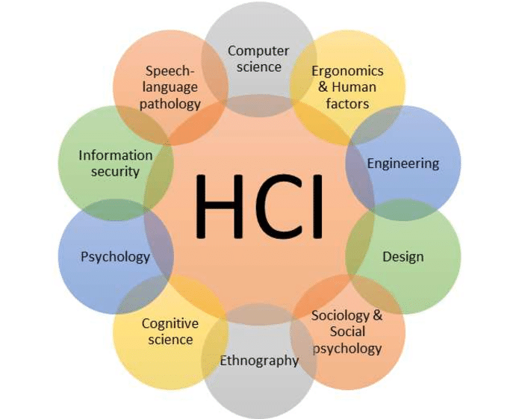

(b) Dix (2004) stated that, *“It is not possible to design effective interactive systems from one discipline in isolation*”. Explain why this is the case.

HCI is a study that involved more than 1 discipline, unlike computer science or software engineering. HCI requires inputs from many different fields and we are not expert in each of them. For example, to build a digital kiosk, have to analyse environment, users’ actions/minds (psychology, cognitive science), system’s technical (computer software engineering) and usability tests (psychology), design skills (use of graphics, colours) . All from different fields.

